Objectives
- Explain the need and Benefits of component life cycle
- Identify various life cycle hook methods
- List the sequence of steps in rendering a component

In this hands-on lab, you will learn how to:
- Implement componentDidMount() hook
- Implementing componentDidCatch() life cycle hook.

Prerequisites

The following is required to complete this hands-on lab:
- Node.js
- NPM
- Visual Studio Code

Notes

Estimated time to complete this lab: 60 minutes.

- Create a new react application using create-react-app tool with the name as “blogapp”
- Open the application using VS Code
- Create a new file named as Post.js in src folder with following properties

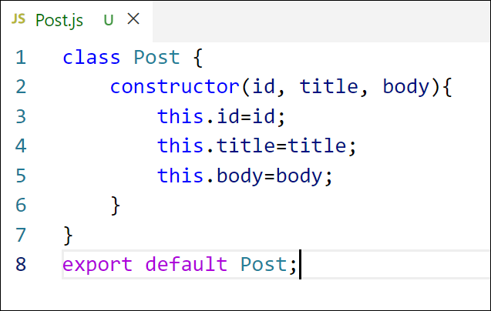
Figure 2: Post class
- Create a new class based component named as Posts inside Posts.js file
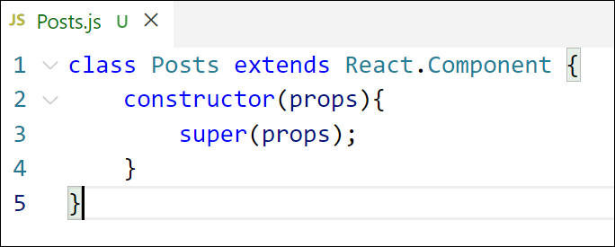
Figure 3: Posts Component
- Initialize the component with a list of Post in state of the component using the constructor
- Create a new method in component with the name as loadPosts() which will be responsible for using Fetch API and assign it to the component state created earlier. To get the posts use the url (https://jsonplaceholder.typicode.com/posts)

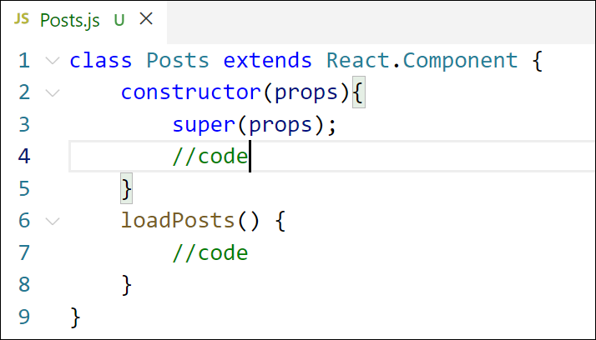
Figure 4: loadPosts() method
- Implement the componentDidMount() hook to make calls to loadPosts() which will fetch the posts

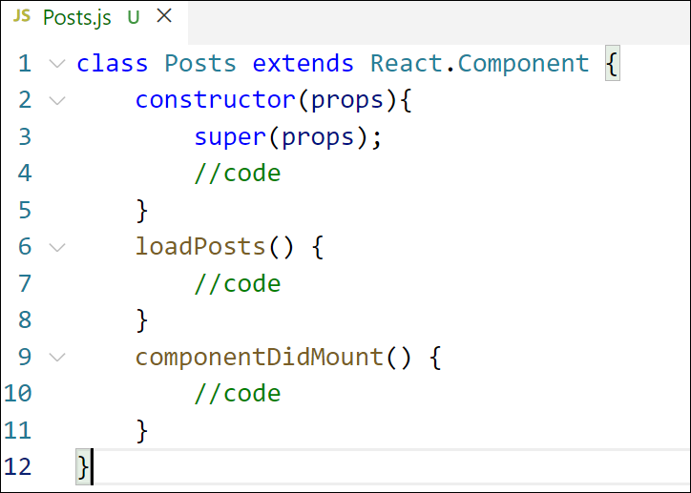
Figure 5: componentDidMount() hook
- Implement the render() which will display the title and post of posts in html page using heading and paragraphs respectively.

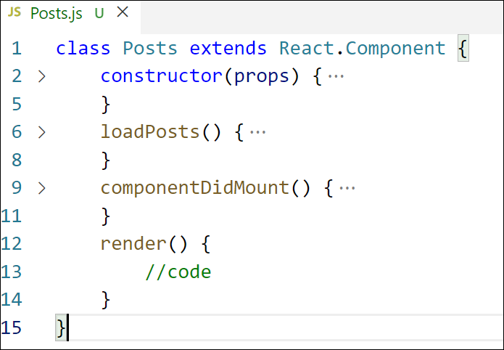
Figure 6: render() method
- Define a componentDidCatch() method which will be responsible for displaying any error happing in the component as alert messages.

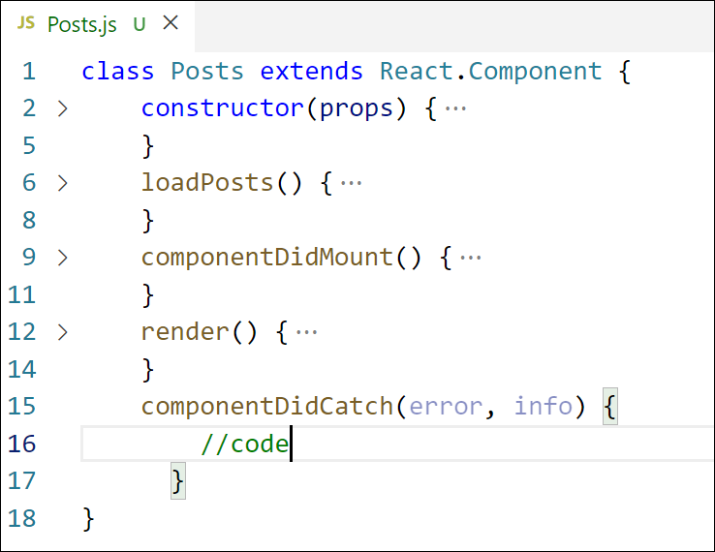
Figure 7: componentDidCatch() hook
- Add the Posts component to App component.
- Build and Run the application using npm start command.
